**Proposal**

Idea: Space Control Station

Description: You play as a leader of a space station. You’re role is to direct Space Ships to the space station while avoiding contact with other Space Ships or asteroids. You also have to defend your station from incoming asteroids.

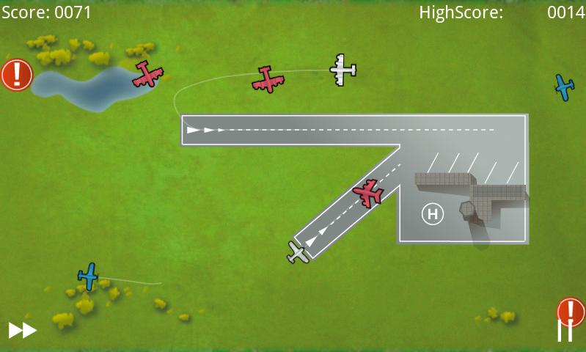

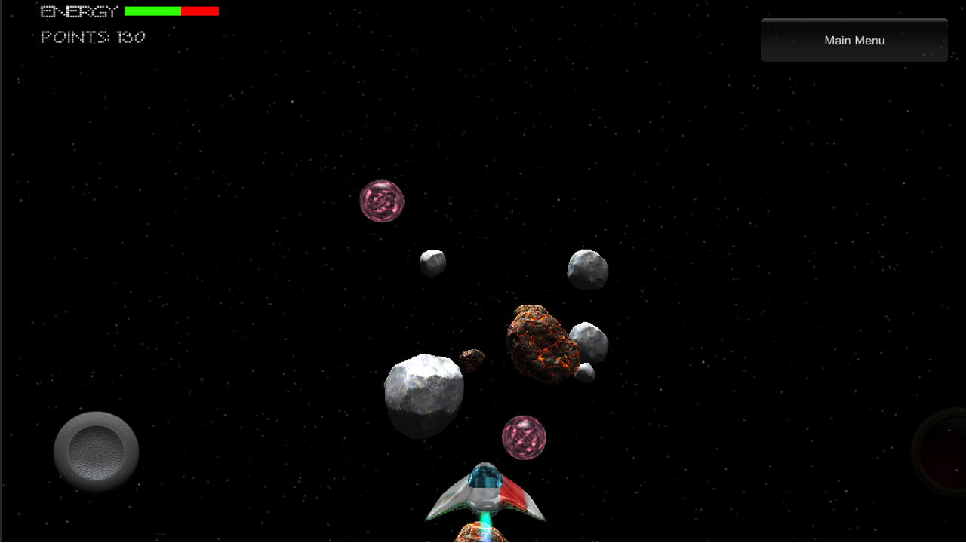

Skybox Size: 1000 X 1000 X 1000;

OBJS: Control panels (to navigate between areas), NPCs, Spaceships, Asteroids, Main Ship.

Characters: 5 Space Station Crew, 4 Space Ships, 1 annoying sidekick.

NPC: Ships, Crew members, Quest NPCs.

Scenario: Defend the station from asteroid, direct the ships to station, walking around space station to talk to NPCs.

Interactions: Bullets Collision, talking to NPC, moving ships to the station.